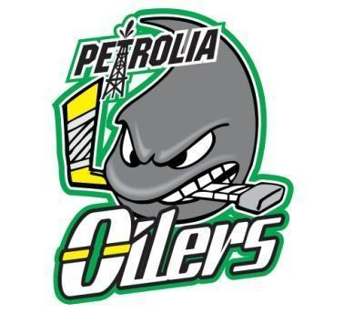

PMHA Board of Directors Meeting

Date: August 9/23
Time: ￼8pm
Location: Crabby Joe’s
Chair: ￼ Mike Edgar
Present: Karis Sylvester, David Hogan, Don Mitchell, Mike Nesdoly, Dan Wellington, Justen Richards, Rob Wilson, Tyler Scott, Chris Currie,
Regrets: Jay Reidhead, Christine Anderson, Nicole Veenema, Amy Burrows

Agenda

- Welcome: Mike E welcomed everyone to the meeting.

2. a) ￼Approval of Last Minutes: deferred till updated- Mike N to complete

Motion to Approve Last Minutes: deferred
Second:deferred

b) ￼Business Arising from the Minutes: n/a

3. Standing Agenda Items:

Treasurer Report (David):

- Received Cheque from Sarnia Sting Assist for $10000
  - Mike E will talk with Amy to determine if we will continue at the Farmers Market

Please see attached reports

Motion to Approve Treasurers Report: Dan W

Second: Tyler S

Registrar Update (David/Christine/Tyler) N/A

OMHA Update (Nicole)
- Suggested that there be 2 MD teams at U9 level and Tier 1 and Tier 2
  - (60 registered) 4 teams total

Shamrock League Coordinator (Don)
- Don sent out the meeting minutes from Aug 8/23 for review
  - Inclimate weather is the travelling teams decision. Must be agreed with both teams.
  - GameSheet needs to be uploaded within 48 hours of the game
  - AllStar game will be in Lucan this season

House League Coordinator (Tyler )

Four-county Coordinator (Chris)
- AGM is next Tuesday and will have more info
- Motion was made for U8/U9 teams and passed

Initiation Program Co-Coordinator (Tyler)
- 54 players, no parents on ice just coaches and helpers
- Helpers/volunteers will need to have the required training
- Tyler will send a list of helpers to Dan to be sure they all receive a training package
- U7 – coaches will have one top tier and one lower tier team to coach

Bingo/Volunteer Coordinator (Amy)

- Karis and Amy to create a volunteer sign up genius and post to website for start of season

Clinics/Concussion Protocol Coordinator (Dan)
- TPH will likely do the checking clinic before end of August.
- Dan will send out an email to U15/U13 player for the checking clinic
- Looking at more VStride clinics, Scott Jones and Windsor Goalie group.
- Derek Dimuzio is also wnating to be involved
  - Continue with Sunshine skates
  - Concussion packages are ready and will be sent out to trainers

Equipment Coordinator (Jay)
- Socks are in
  - U5 and U7 jerseys and socks have been ordered

AAA Report: N/a

Communications Co-Ordinator (Karis)
- Post try out schedule to website and socials
- Set up Justen email contact Acute

Sponsorship/ Fundraising (Justen):
- Need volunteers for the gates at the Petrolia Fair
- Justen has some sponsorships

Ice Scheduler (Rob)
- Try out and Preskates are up
- Game times are being looked at

Referees (Rob)
- Usually have a meeting in mid September

Coaches Committee (Mike N)
- All coaches have been selected
- Registration has been sent to all teams
  - U11- 38 1goalie
  - U 9 – 60 players 2 goalies
  - U13 41 and 4 goalies
  - U15 37 and 2 goalies (need goalie relief)
  - U18 45 and 4 goalies

4. Items for Discussion:

- Mental Health email: seems expensive so Mike will inform that we are not interested

- Try Outs to a higher level. It is done by numbers.

- Coaches Certification: Packages sent to coaches. Coaches responsible for their bench training being completed.

- Dan needs 21 people signed up for D1 training.

5. Next Meeting: Sept 13th at Crabby Joes

6. Motion for Adjournment: Justen
Second: Chris
Time: 9:47 pm

